2 ReactJS-HOL-HANDS-ON-ANSWERS
We create the React application using the following command in the VS Code terminal –
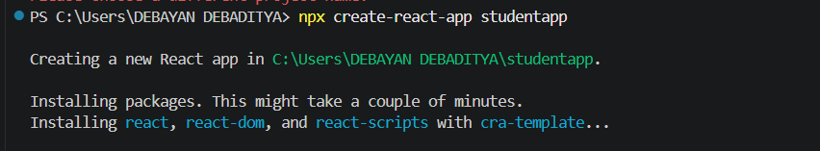
A new folder named ‘Components’ has been created under the ‘src’ folder which consists of the ‘Home.js’ file.
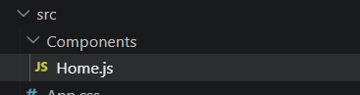
Then we write the following code inside the Home.js file –
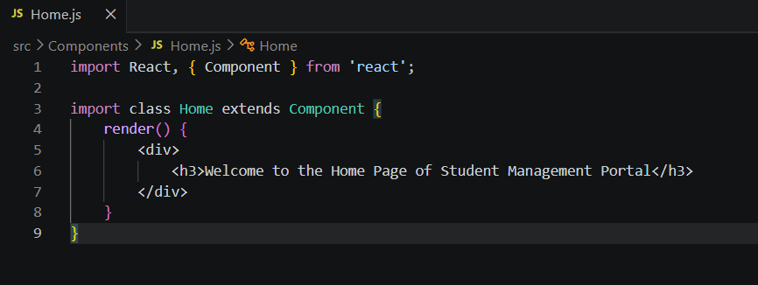
Again, the files named ‘About.js’ and “Contact.js” under ‘src’ has been added.
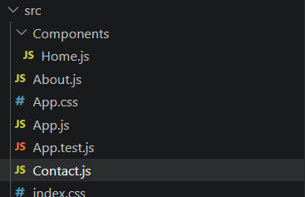

The structure of App.js after making the necessary changes are shown here
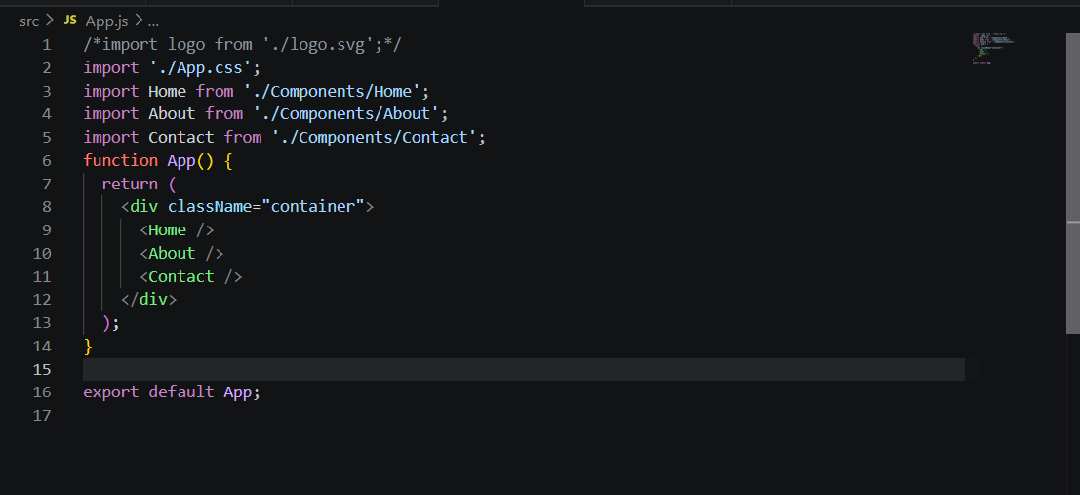
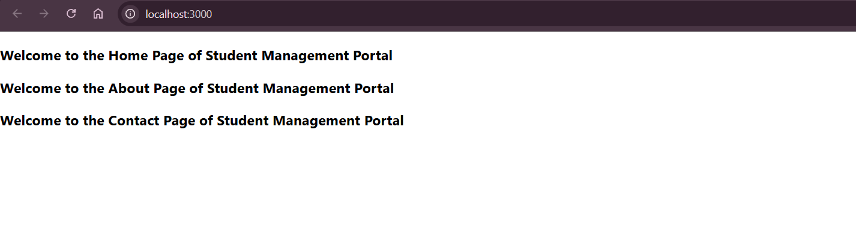
And the result is this –

